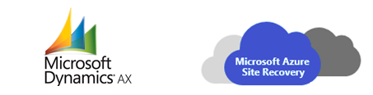

Automated Disaster Recovery Solution for Microsoft Dynamics AX using Azure Site Recovery

**Summary:** This document provides technical guidance for implementing one-click disaster recovery solution for Microsoft Dynamics AX application using Azure Site Recovery.

**Published:** September 2015

**Applies to:** Microsoft Dynamics AX application, Azure Site Recovery

Copyright and Disclaimer

© 2015 Microsoft Corporation.  All rights reserved.

This document is provided "as-is”. Information and views expressed in this document, including URL and other Internet Web site references, may change without notice. You bear the risk of using it.   
This document does not provide you with any legal rights to any intellectual property in any Microsoft product. You may copy and use this document for your internal, reference purposes. You may modify this document for your internal, reference purposes.

Automated Disaster Recovery Solution for Microsoft Dynamics AX application using Azure Site Recovery 3

Overview 3

Dynamics AX architecture 4

Supported Azure Site Recovery Deployment Options 5

Prerequisites 6

Enable DR of Dynamics AX application using ASR 6

Protect your Dynamics AX application 6

Setup AD and DNS replication 6

Setup SQL Server replication 7

Enable protection for Dynamics AX client and AOS VMs 7

Configure Networking 7

Create a recovery plan 11

Perform a Test Failover 13

Perform an Unplanned Failover 14

Perform a Planned Failover 15

Perform a Failback 15

Best Practices 17

Capacity planning and readiness assessment 17

Implementation Checklist 17

Summary 18

Appendix (Scripts) 19

Automated Disaster Recovery Solution for Microsoft Dynamics AX application using Azure Site Recovery

Overview

Microsoft Dynamics AX is one of the most popular ERP solution among enterprises to standardized process across locations, manage resources and simplifying compliance. Considering the application is business critical to an organization it is very important to be sure that in case of any disaster, application should be up and running in minimum time.

Today, Microsoft Dynamics AX[1] does not provide any out-of-the-box disaster recovery capabilities. Regardless of the type and scale of a disaster, recovery involves the use of a standby data center that you can recover the complete application to. Standby data centers are required for scenarios where local redundant systems and backups cannot recover from the outage at the primary data center. Microsoft Dynamics AX consists of many server components like Application Object Server, Active Directory (AD), SQL Database Server, SharePoint Server, Reporting Server etc. To manage the disaster recovery of each of these components manually is not only expensive but also error-prone.

Azure Site Recovery[2] is an Azure based service that provides disaster recovery capabilities by orchestrating replication, failover and recovery of virtual machines. Azure Site Recovery supports a number of replication technologies to consistently replicate, protect, and seamlessly failover virtual machines and applications to private/public or hoster’s clouds. ***Azure Site Recovery based disaster recovery solution is fully tested, certified and recommended by Microsoft Dynamics AX.***

This document explains in detail about how you can create a disaster recovery solution for your Dynamics AX application, perform a planned/unplanned/test failovers using one-click recovery plan, supported configurations and prerequisites.

Dynamics AX architecture

Dynamics AX can be deployed on one or more servers using tiered topologies and server roles to implement a design that meets specific goals and objectives. Dynamics AX consists of many server components like Application Object Server, Active Directory (AD), SQL Database Server, SharePoint Server, Reporting Server etc.

The below figures illustrate the topology of a typical large scale intranet-only and internet facing enterprise deployments of Dynamics AX.

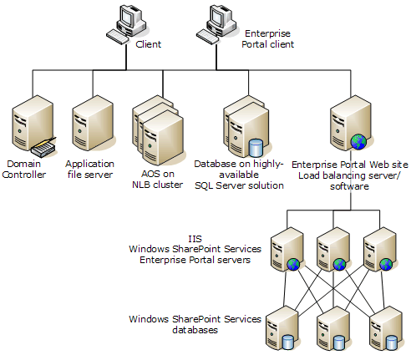

***Intranet-only deployment of Dynamics AX***

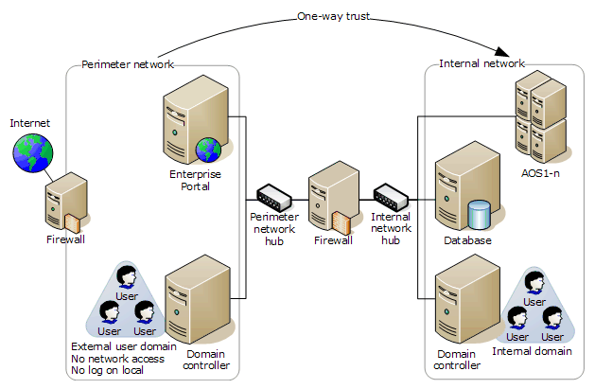

***Internet Facing Deployment (IFD) of Dynamics AX***

Supported Azure Site Recovery Deployment Options

Customers can deploy Dynamics AX as Virtual Machines running on Hyper-V or VMware or as Physical Servers. Azure Site Recovery can protect both physical and virtual deployments to either a secondary Site or to Azure.

|  |  |  |  |  |  |
| --- | --- | --- | --- | --- | --- |
| ***Hyper-V*** | | ***VMware*** | | ***Physical*** | |
| **Site to Site** | **Site to Azure** | **Site to Site** | **Site to Azure** | **Site to Site** | **Site to Azure** |
| Yes | Yes | Yes | Yes | Yes | Yes |

Prerequisites

Implementing disaster recovery for Dynamics AX application using Azure Site Recovery requires the following pre-requisites completed.

* An on-premises Dynamics AX deployment has been setup
* Azure Site Recovery Services vault has been created in Microsoft Azure subscription[3]
* If Azure is your recovery site, run the Azure Virtual Machine Readiness Assessment tool[4] on VMs to ensure that they are compatible with Azure VMs and Azure Site Recovery Services.

Enable DR of Dynamics AX application using ASR

Protect your Dynamics AX application

Each component of the Dynamics AX needs to be protected to enable the complete application replication and recovery. This section covers:

* Protection of Active Directory
* Protection of SQL Tier
* Protection of App and Web Tiers
* Networking configuration

Setup AD and DNS replication

Active Directory is required on the DR site for Dynamics AX application to function. There are two recommended choices based on the complexity of the customer’s on-premises environment.

Option 1

If the customer has a small number of applications and a single domain controller for his entire on-premises site and will be failing over the entire site together, then we recommend using ASR-Replication to replicate the DC machine to secondary site (applicable for both Site to Site and Site to Azure)

Option 2

If the customer has a large number of applications and is running an Active Directory forest and will failover few applications at a time, then we recommend setting up an additional domain controller on the DR site (secondary site or in Azure).

Please refer to companion guide[5] on making a domain controller available on DR site. For remainder of this document we will assume a DC is available on DR site*.*

Setup SQL Server replication

Please refer to companion guide[6] for detailed technical guidance on the recommended option for protecting SQL tier.

Enable protection for Dynamics AX client and AOS VMs

Enable protection of AX client and AOS VMs in ASR. Perform relevant Azure Site Recovery configuration based on whether the VMs are deployed on Hyper-V or on VMware.

* Recommended Crash consistent frequency to configure is 15minutes.

The below snapshot shows the protection status of Dynamics component VMs in ‘Hyper-V site to Azure’ protection scenario.

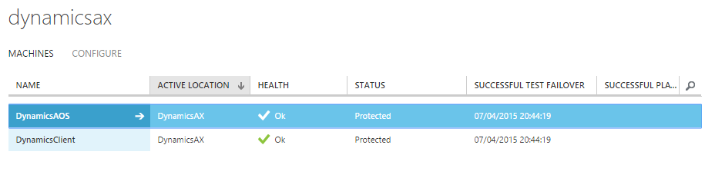

Configure Networking

Configure VM Network Settings

For the AX client and AOS VMs configure network settings in ASR so that the VM networks get attached to the right DR network after failover. Ensure the DR network for these tiers is routable to the SQL tier.

You can select the VM in the ‘VMM Cloud’ or the ‘Protection Group’ to configure the network settings as shown in the snapshot below.

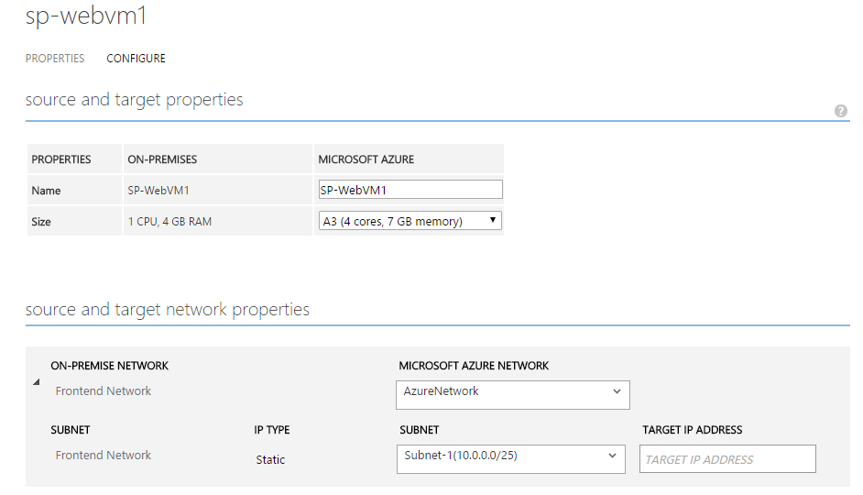

Configure DNS and Traffic Routing

For internet facing sites, create an instance of Traffic Manager in the Azure subscription and configure it and your DNS in the following manner.

|  |  |  |
| --- | --- | --- |
| Where | Source | Target |
| Public DNS | Public DNS for Dynamics AX sites  Ex: Dynamic AX.contoso.com | Traffic Manager  contosoDynamicsAX.trafficmanager.net |
| On-premises DNS | DynamicsAXonprem.contoso.com | <Public IP on the on-premises site> |

|  |
| --- |
| Load balancing method: Failover  Failover Priority list:   1. <URL configured for Primary site> 2. <URL configured for Recovery site>   Example:   1. Dynamics AXpri.contoso.com 2. DynamicsAXrec.contoso.com |

Host a test page on a specific PORT (e.g. 800) in the Dynamics AX web tier in order for Traffic Manager to automatically detect availability post failover. This is a workaround in case you cannot enable anonymous authentication on any of your Dynamics AX sites.

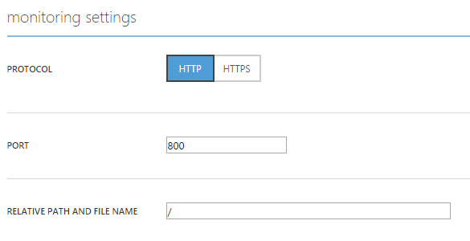

Once failover to the recovery cloud happens, this policy will result in the following and the traffic will start getting routed to the recovery site side.

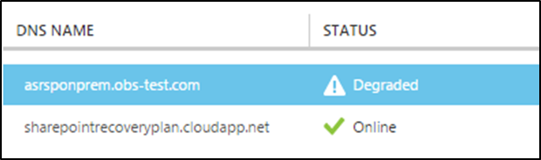

For internal only sites, skip Traffic Manager and create DNS entries in the following manner.

|  |  |  |
| --- | --- | --- |
|  | Source | Target |
| On-premises DNS | Internal URL  Ex: https://DynamicsAXonprem.contoso.com | Default site name  https://<WebTierVMName>  or Load balancer IP |

The following pictures illustrate the network topology of the Dynamics AX application in E2E and E2A scenarios once the complete protection is enabled using Azure Site Recovery.

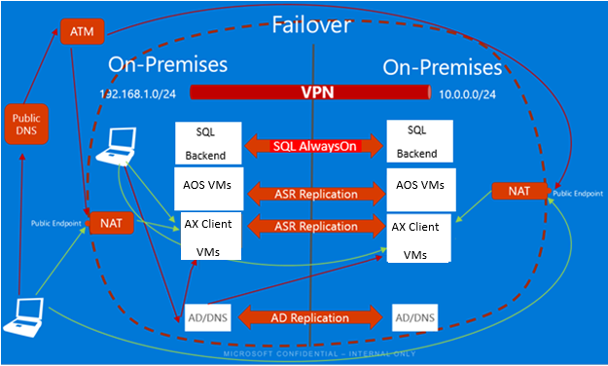

***Network topology for Site to Site scenario***

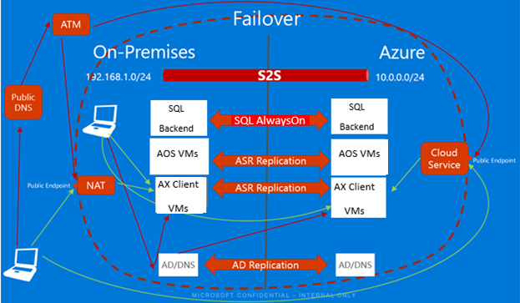

***Network topology for Site to Azure scenario***

Create a recovery plan

You can create a recovery plan in ASR to automate the failover process. Add app tier and web tier in the Recovery Plan. Order them in different groups so that the front-end shutdown before app tier.

1. Select the ASR vault in your subscription and click on ‘Recovery Plans’ tab.
2. Click on ‘Create’ and specify a name
3. Select the ‘Source’ and ‘Target’. The target can be Azure or secondary site.

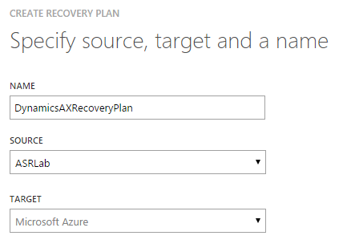

1. Select the AOS and client VMs to the recovery plan and click ✓.

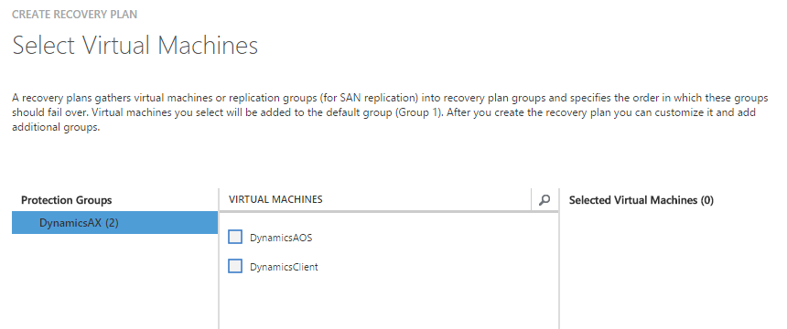

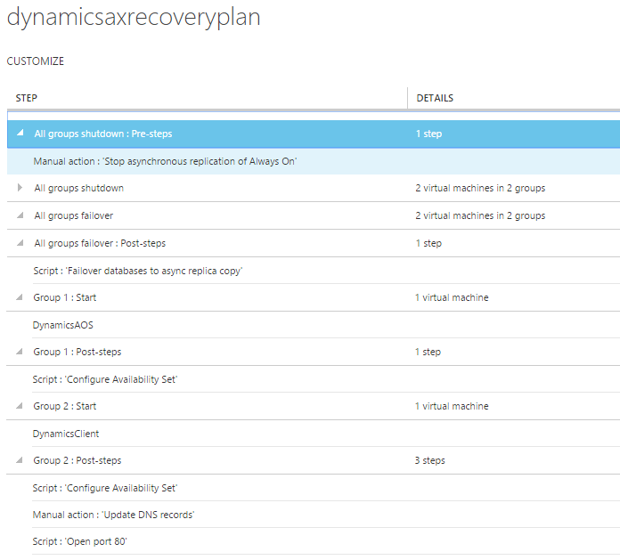

You can customize the recovery plan for Dynamics AX application by adding various steps as detailed below. The above snapshot shows the complete recovery plan after adding all the steps.

##### Steps:

###### SQL Server failover steps

Refer to ‘SQL Server DR Solution’ companion guide[7] for details about recovery steps specific to SQL server.

###### Failover Group 1: Failover the AOS VMs

Make sure that the recovery point selected is as close as possible to the database PIT but not ahead.

###### Script 1: Configure availability set (Only E-A)

Add a script (via Azure automation) after AOS VM group comes up to create an availability set and add the App tier VMs into the availability set. You can use a script to do this task.

###### Failover Group 2: Failover the AX client VMs.

Failover the web tier VMs as part of the recovery plan.

###### Script 2: Configure availability set (Only E-A)

Add a script (via Azure automation) after Client VM group comes up to create an availability set and add the Web tier VMs into the availability set. You can use a script to do this task.

###### Manual step 4: Update the DNS records to point to the new VMs in Azure.

For internet facing sites, no DNS update should be required post failover. Follow the steps described in the previous section to configure Traffic Manager. If Traffic Manager has been setup as described in the previous section, add a script to open dummy port (800 in the example) on the recovery side.

For internal facing sites, add a manual step to update the DNS record to point to the new front end VM’s load balancer IP.

###### Script 4: Open port 80 (only E-A)

Add an Azure automation script to add HTTP endpoint at Port 80 on the front-end VMs. Repeat the same for the Traffic Manager Port added in the previous section.

*Refer to* *Open Azure endpoints script* *in Appendix section*

Perform a Test Failover

Refer to ‘AD DR Solution[8]’ and ‘SQL Server DR solution[9]’ companion guides for considerations specific to AD and SQL server respectively during Test Failover.

1. Go to Azure manage portal and select your Site Recovery vault.
2. Click on the recovery plan created for Dynamics AX.
3. Click on ‘Test Failover’.
4. Select the virtual network to start the test failover process.

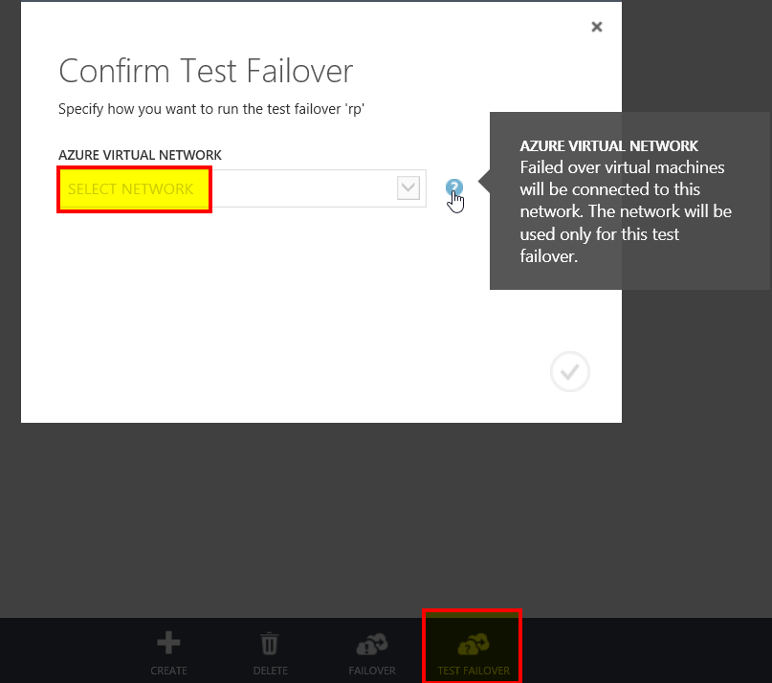

1. Once the secondary environment is up, you can perform your validations.
2. Once the validations are complete, you can select ‘Validations complete’ and the test failover environment will be cleaned.

Perform an Unplanned Failover

1. Go to Azure manage portal and select your Site Recovery vault.
2. Click on the recovery plan created for Dynamics AX.
3. Click on ‘Failover’ and select ‘Unplanned Failover’.

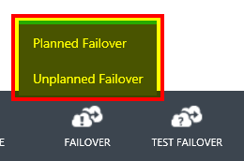

1. Select the target network and click ✓ to start the failover process.

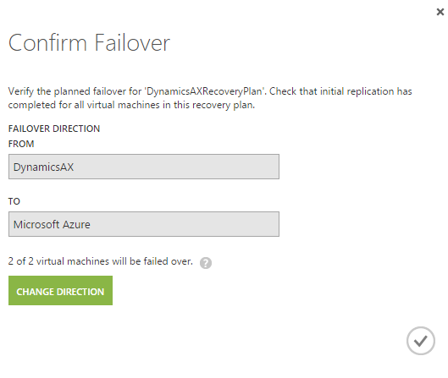

Perform a Planned Failover

1. Go to Azure manage portal and select your Site Recovery vault.
2. Click on the recovery plan created for Dynamics AX.
3. Click on ‘Failover’ and select ‘Planned Failover’.
4. Select the target network and click ✓ to start the failover process.

Perform a Failback

Refer to ‘SQL Server DR Solution[10]’ companion guide for considerations specific to SQL server during Failback.

1. Go to Azure manage portal and select your Site Recovery vault.
2. Click on the recovery plan created for Dynamics AX.
3. Click on ‘Failover’ and select planned/unplanned failover.
4. Click on ‘Change Direction’.
5. Select the appropriate options - data synchronization and VM creation options
6. Click ✓ to start the ‘Failback’ process.

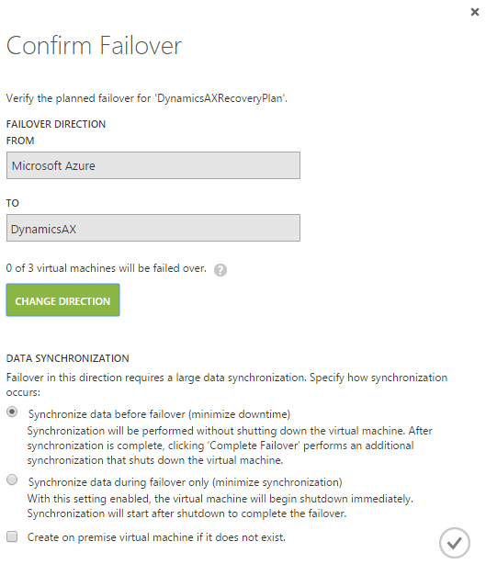

Best Practices

Capacity planning and readiness assessment

Hyper-V site

User Capacity planner tool[11] to design the server, storage and network infrastructure for your Hyper-V Replica environment.

Azure

You can run the Azure Virtual Machine Readiness Assessment tool[12] on VMs to ensure that they are compatible with Azure VMs and Azure Site Recovery Services. The Readiness Assessment Tool checks VM configurations and warns when configurations are incompatible with Azure. For example, it issues a warning if a C: drive is larger than 127 GB.

Capacity planning is made up of at least two important components:

* Mapping on-premises Hyper-V VMs to Azure VM sizes (such as A6, A7, A8, and A9).
* Determining the required Internet bandwidth.

Implementation Checklist

|  |  |  |  |  |
| --- | --- | --- | --- | --- |
| **Step 1** |  |  |  |  |
| Create Azure Site Recovery vault in Microsoft Azure subscription. | | | | |
| Check the prerequisites to protect your Dynamics AX application. | | | | |
| **Step 2** |  |  |  |  |
| Hyper-V only step - Download Microsoft Azure Site Recovery Provider, and install it on VMM server / Hyper-V host | | | | |
| VMware only step - Configure Protection server, Configuration server and Master Target servers appropriately | | | | |
|  |  |  |  |  |
| **Step 3** |  |  |  |  |
| Prepare resources. | | | |  |
| Add an Azure Storage account. | | |  |  |
| Hyper-V only step - Download the Microsoft Azure Recovery Services Agent, and install it on Hyper-V host servers. | | | | |
| VMware only step – Make sure the mobility service is installed on all the VMs | | | | |
|  |  |  |  |  |
| **Step 4** |  |  |  |  |
| Enable protection for VMs in VMM clouds / Hyper-V sites / VMware sites | | | | |
|  |  |  |  |  |
| **Step 5** |  |  |  |  |
| Map resources. Map on premise networks to Azure VNET. | | | |  |
|  | | | |  |
| **Step 7** |  |  |  |  |
| Create the recovery plan | | | | |
| Perform test failover using the recovery plan | | | | |
| Ensure that all VMs have access to required resources, such as Active Directory | | | | |
| Ensure that network redirections for Dynamics AX are working | | | | |
|  | | | | |
| **Step 8** | | | | |
| Perform DR drill using planned and unplanned failovers | | | |  |
| Ensure that all VMs have access to required resources, such as Active Directory | | | | |
| Ensure that network redirections for Dynamics AX are working | | | |  |

Summary

Using Azure Site Recovery, you can create a complete automated disaster recovery plan for your Dynamics AX application. You can initiate the failover within seconds from anywhere in the event of a disruption and get the application up and running in a few minutes.

Appendix (Scripts)

# Script to Open End Points in Azure



1. [Dynamics AX deployment resources for IT Pros](https://technet.microsoft.com/en-us/library/gg852966.aspx)
2. [Azure Site Recovery documentation](https://azure.microsoft.com/en-us/documentation/services/site-recovery/)
3. [Create Azure Site Recovery vault](https://azure.microsoft.com/en-us/documentation/articles/site-recovery-vmm-to-azure/) in Microsoft Azure subscription
4. [Azure Virtual Machine Readiness Assessment](http://azure.microsoft.com/en-us/downloads/vm-readiness-assessment/)
5. [Setting up AD for a DR environment](http://aka.ms/asr-ad)
6. [Protect SQL Tier](http://aka.ms/asr-sql)
7. [Protect SQL Server](http://aka.ms/asr-sql)
8. [Protect AD](http://aka.ms/asr-ad)
9. [Protect SQL Server](http://aka.ms/asr-sql)
10. [Protect SQL Server](http://aka.ms/asr-sql)
11. [Hyper-V Replica Capacity Planner tool](http://www.microsoft.com/en-us/download/details.aspx?id=39057)
12. [Azure Virtual Machine Readiness Assessment tool](http://azure.microsoft.com/en-us/downloads/vm-readiness-assessment/)